Partial / residual correlation: NZDUSD and USDCHF
Method 07 / daily log returns / leave-currency-out USD factor / Alpari D1 full available history

Study setup
Logical pair: NZDUSD , USDCHF
Broker symbols: NZDUSD_i , USDCHF_i
Snapshot: 2026-11-03_majors_alpari_D1
Timeframe: D1
Matched return window: 1999-01-05 to 2026-11-02 (UTC bar dates)
Matched return count n: 7148
Dropped unfinished last bar dated 2026-11-03 UTC after a tick-volume check against the prior complete day.
USD-strength sign rule: minus log return when USD is the quote (EURUSD, GBPUSD, AUDUSD, NZDUSD); plus log return when USD is the base (USDJPY, USDCHF, USDCAD). EURGBP is never a constituent.
Control z constituents (5): EURUSD, GBPUSD, AUDUSD, USDJPY, USDCAD
z_t = equal-weight mean of those USD-strength returns on the same day
Complete matched rows (Excel): NZDUSD-USDCHF_Partial_D1.xlsx
Complete matched rows (HTML table): NZDUSD-USDCHF_Partial_D1_data.html

Method carried forward
Partial / residual correlation regresses each matched daily log return of close, ln(close_t / close_t-1), on the same leave-currency-out USD strength factor z, then takes Pearson correlation of the two residual series. Quotes are not inverted. z is the equal-weight mean of USD-strength returns from other majors that do not share a non-USD currency with either leg; EURGBP is never a constituent. USD-strength is minus the log return when USD is the quote (EURUSD, GBPUSD, AUDUSD, NZDUSD) and plus the log return when USD is the base (USDJPY, USDCHF, USDCAD). OLS uses an intercept on each leg. rho_partial is symmetric under swap of the two symbols. It describes leftover linear co-movement after removing linear z; it is not a cause, not a lead, and not a trading signal. Daily rows are not independent and residuals are estimated, so the two-sided p-value and Fisher interval are secondary. Same-sample raw Pearson r is a side check only.

Regression on z
leg | intercept_a_or_c | slope_b_or_d | R2
NZDUSD | 2.728e-05 | -1.3161056 | 0.56180708
USDCHF | -7.547e-05 | 0.97304153 | 0.41284518

Results
rho_partial: 0.173657
Two-sided p-value: 1.65232e-49
Approximate 95% Fisher interval: [0.151082, 0.196050]
Same-sample raw Pearson r: -0.393516
rho_partial minus r: 0.567173

Conclusion
Over 7148 matched daily rows for NZDUSD and USDCHF after removing a leave-currency-out USD factor built from 5 constituents, rho_partial is 0.1737 (positive, weak residual linear link in this sample). Approximate 95% Fisher interval: [0.1511, 0.1961]. Same-sample raw Pearson r is -0.3935 (partial minus r = 0.5672). Leg R-squared on z: NZDUSD=0.5618, USDCHF=0.4128. Two-sided p under the usual independent-pairs model is 1.652e-49; residuals are estimated and daily FX rows are linked, so treat p as secondary. This does not establish cause, lead-lag, or a lasting trading rule.

Charts
Daily closes
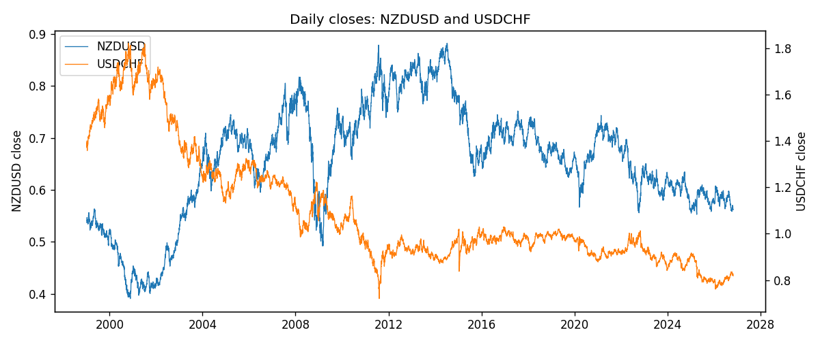
Log returns and control z
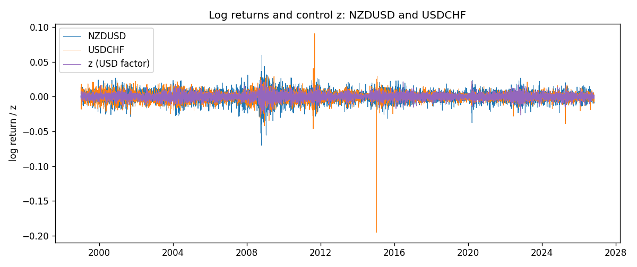
Residual scatter e_x vs e_y
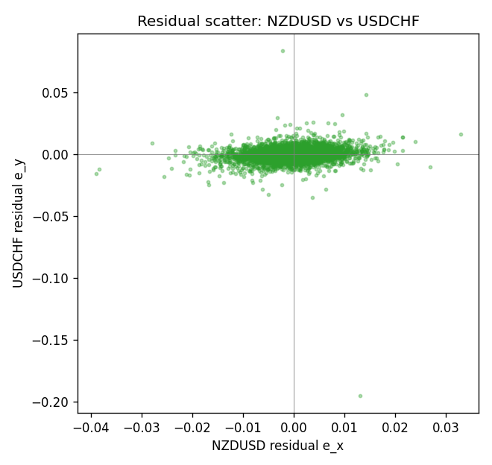

Data report
Every matched row that entered the partial correlation is stored in the sibling Excel workbook named NZDUSD-USDCHF_Partial_D1.xlsx. That file is the complete data archive for redrawing charts. Embedding all rows as a Word table is impractical at this length; the Word file holds the column list, column summaries, and the first and last 15 matched rows.
Columns: time, NZDUSD_open, USDCHF_open, NZDUSD_high, USDCHF_high, NZDUSD_low, USDCHF_low, NZDUSD_close, USDCHF_close, NZDUSD_tick_volume, USDCHF_tick_volume, NZDUSD_spread, USDCHF_spread, NZDUSD_real_volume, USDCHF_real_volume, NZDUSD_log_return, USDCHF_log_return, usd_strength_EURUSD, usd_strength_GBPUSD, usd_strength_AUDUSD, usd_strength_USDJPY, usd_strength_USDCAD, z, NZDUSD_fitted, USDCHF_fitted, NZDUSD_resid, USDCHF_resid
Column summaries (matched calculation rows)
column | count | mean | std | min | 25% | 50% | 75% | max
NZDUSD_open | 7148 | 0.65680048 | 0.1080291 | 0.3913 | 0.5917475 | 0.668695 | 0.72504 | 0.88218
USDCHF_open | 7148 | 1.0960885 | 0.25173228 | 0.72022 | 0.9203525 | 0.9894 | 1.2355 | 1.8219
NZDUSD_high | 7148 | 0.66072183 | 0.10852081 | 0.3961 | 0.595065 | 0.67222 | 0.729525 | 0.88421
USDCHF_high | 7148 | 1.101368 | 0.25346299 | 0.73305 | 0.9245 | 0.993025 | 1.240225 | 1.8313
NZDUSD_low | 7148 | 0.65311385 | 0.10762321 | 0.3897 | 0.588355 | 0.66451 | 0.72113 | 0.87988
USDCHF_low | 7148 | 1.0909798 | 0.25015306 | 0.08565 | 0.9169075 | 0.98582 | 1.229425 | 1.8121
NZDUSD_close | 7148 | 0.65687963 | 0.10802405 | 0.3907 | 0.592165 | 0.66876 | 0.72518 | 0.8822
USDCHF_close | 7148 | 1.0960817 | 0.25162815 | 0.72025 | 0.92048 | 0.989445 | 1.2352 | 1.8217
NZDUSD_tick_volume | 7148 | 69051.458 | 123370.73 | 17 | 5742 | 34119 | 58667.5 | 1127682
USDCHF_tick_volume | 7148 | 74666.538 | 113693.11 | 350 | 12884 | 40421 | 70666.5 | 858589
NZDUSD_spread | 7148 | 30.128428 | 25.588679 | 0 | 9 | 17 | 40 | 80
USDCHF_spread | 7148 | 25.894096 | 24.64185 | 0 | 5 | 16 | 50 | 100
NZDUSD_real_volume | 7148 | 1.678526e+10 | 8.5194876e+10 | 0 | 0 | 0 | 0 | 2.705649e+12
USDCHF_real_volume | 7148 | 2.3408849e+10 | 8.9348471e+10 | 0 | 0 | 0 | 0 | 1.9331921e+12
NZDUSD_log_return | 7148 | 1.914e-05 | 0.00764519 | -0.07027433 | -0.00424201 | 0.00023666 | 0.004586 | 0.05966839
USDCHF_log_return | 7148 | -6.945e-05 | 0.0065937 | -0.19545699 | -0.00334697 | 8.15e-05 | 0.00331954 | 0.09051364
usd_strength_EURUSD | 7148 | 2.16e-06 | 0.0058013 | -0.03433183 | -0.00325609 | -0 | 0.00324218 | 0.03123819
usd_strength_GBPUSD | 7148 | 1.992e-05 | 0.00564699 | -0.03112653 | -0.00318167 | -3.426e-05 | 0.0031217 | 0.08388241
usd_strength_AUDUSD | 7148 | -3.157e-05 | 0.00755018 | -0.0806166 | -0.00415111 | -0.00029168 | 0.00385014 | 0.08602525
usd_strength_USDJPY | 7148 | 5.267e-05 | 0.00620906 | -0.03908203 | -0.00319392 | 0.00012736 | 0.00340928 | 0.05184024
usd_strength_USDCAD | 7148 | -1.226e-05 | 0.00514518 | -0.03859748 | -0.00283513 | 4.873e-05 | 0.00272781 | 0.03436319
z | 7148 | 6.18e-06 | 0.00435403 | -0.02656036 | -0.00250632 | 2.027e-05 | 0.00249974 | 0.02379694
NZDUSD_fitted | 7148 | 1.914e-05 | 0.00573036 | -0.03129201 | -0.00326265 | 6e-07 | 0.00332586 | 0.03498352
USDCHF_fitted | 7148 | -6.945e-05 | 0.00423665 | -0.0259198 | -0.00251422 | -5.575e-05 | 0.00235689 | 0.02307995
NZDUSD_resid | 7148 | 0 | 0.00506082 | -0.03898232 | -0.00268367 | 9.112e-05 | 0.00287198 | 0.03289033
USDCHF_resid | 7148 | -0 | 0.00505249 | -0.19519283 | -0.00224855 | 0.00012 | 0.00235317 | 0.08382725
First 15 matched rows (selected columns)
time | NZDUSD_close | USDCHF_close | NZDUSD_log_return | USDCHF_log_return | z | NZDUSD_fitted | USDCHF_fitted | NZDUSD_resid | USDCHF_resid
1999-01-05 | 0.5372 | 1.3724 | -0.0018597736 | 0.0039424743 | -0.00035469752 | 0.00049409891 | -0.00042060243 | -0.0023538726 | 0.0043630767
1999-01-06 | 0.5383 | 1.3912 | 0.0020455609 | 0.013605652 | 0.0015102953 | -0.0019604286 | 0.0013941131 | 0.0040059896 | 0.012211539
1999-01-07 | 0.5417 | 1.3782 | 0.0062963171 | -0.0093883841 | -0.0051411507 | 0.0067935768 | -0.0050780202 | -0.00049725975 | -0.0043103639
1999-01-08 | 0.5414 | 1.3935 | -0.00055396548 | 0.011040268 | 0.0019323101 | -0.0025158446 | 0.0018047509 | 0.0019618791 | 0.0092355171
1999-01-11 | 0.547 | 1.4009 | 0.010290425 | 0.0052963193 | -0.0028284322 | 0.003749795 | -0.002827649 | 0.0065406302 | 0.0081239683
1999-01-12 | 0.5441 | 1.3872 | -0.0053157489 | -0.0098275602 | 0.0074029223 | -0.0097157482 | 0.0071278839 | 0.0043999992 | -0.016955444
1999-01-13 | 0.5387 | 1.3621 | -0.0099742238 | -0.018259701 | 0.00011823246 | -0.00012832689 | 3.9578084e-05 | -0.0098458969 | -0.018299279
1999-01-14 | 0.5386 | 1.3588 | -0.00018564931 | -0.0024256692 | 0.0015393875 | -0.0019987171 | 0.001422421 | 0.0018130677 | -0.0038480902
1999-01-15 | 0.5382 | 1.3834 | -0.00074294208 | 0.01794228 | 0.0009259475 | -0.0011913652 | 0.00082551837 | 0.00044842311 | 0.017116762
1999-01-18 | 0.5372 | 1.379 | -0.0018597736 | -0.0031856384 | -0.00094236283 | 0.0012675285 | -0.00099242518 | -0.0031273022 | -0.0021932132
1999-01-19 | 0.5382 | 1.3789 | 0.0018597736 | -7.2518946e-05 | -0.0023596233 | 0.003132793 | -0.0023714785 | -0.0012730193 | 0.0022989595
1999-01-20 | 0.5404 | 1.3889 | 0.0040793678 | 0.0072259871 | -0.00090083037 | 0.0012128674 | -0.00095201238 | 0.0028665004 | 0.0081779994
1999-01-21 | 0.5426 | 1.3836 | 0.0040627941 | -0.0038232689 | -0.00055407207 | 0.00075649688 | -0.00061460215 | 0.0033062973 | -0.0032086667
1999-01-22 | 0.5361 | 1.3834 | -0.012051689 | -0.0001445609 | 0.0039058256 | -0.0051131995 | 0.0037250635 | -0.0069384899 | -0.0038696244
1999-01-25 | 0.5342 | 1.3868 | -0.0035504102 | 0.0024546976 | -0.00014518206 | 0.00021835444 | -0.00021673518 | -0.0037687646 | 0.0026714328
Last 15 matched rows (selected columns)
time | NZDUSD_close | USDCHF_close | NZDUSD_log_return | USDCHF_log_return | z | NZDUSD_fitted | USDCHF_fitted | NZDUSD_resid | USDCHF_resid
2026-10-13 | 0.56127 | 0.83244 | 0.0047326165 | -0.0024955621 | -0.0034834693 | 0.0046118931 | -0.0034650273 | 0.00012072344 | 0.00096946526
2026-10-14 | 0.55918 | 0.83489 | -0.0037306483 | 0.0029388325 | 0.002357658 | -0.0030756475 | 0.0022186322 | -0.00065500079 | 0.00072020028
2026-10-15 | 0.56185 | 0.82676 | 0.0047634855 | -0.0097855323 | -0.0020241655 | 0.0026912952 | -0.0020450641 | 0.0020721903 | -0.0077404682
2026-10-16 | 0.56509 | 0.82377 | 0.0057501001 | -0.0036230826 | -0.0025468607 | 0.0033792171 | -0.0025536682 | 0.002370883 | -0.0010694144
2026-10-19 | 0.56616 | 0.82677 | 0.0018917133 | 0.0036351779 | 0.00016292942 | -0.00018715281 | 8.3070079e-05 | 0.0020788661 | 0.0035521079
2026-10-20 | 0.56827 | 0.8246 | 0.0037199341 | -0.0026281224 | -0.0034807638 | 0.0046083324 | -0.0034623948 | -0.00088839823 | 0.00083427238
2026-10-21 | 0.57003 | 0.82427 | 0.0030923331 | -0.00040027413 | -0.0011419114 | 0.0015301555 | -0.0011865942 | 0.0015621776 | 0.00078632009
2026-10-22 | 0.56815 | 0.82032 | -0.0033035227 | -0.0048036381 | -0.0017173476 | 0.0022874904 | -0.0017465176 | -0.005591013 | -0.0030571205
2026-10-23 | 0.56991 | 0.82497 | 0.0030929853 | 0.005652514 | 0.00029120186 | -0.00035597289 | 0.00020788449 | 0.0034489582 | 0.0054446295
2026-10-26 | 0.56826 | 0.82649 | -0.0028993932 | 0.0018407959 | 0.0024177972 | -0.003154797 | 0.0022771501 | 0.00025540384 | -0.00043635417
2026-10-27 | 0.56811 | 0.82865 | -0.00026399852 | 0.0026100526 | 0.002030661 | -0.0026452849 | 0.0019004505 | 0.0023812864 | 0.00070960207
2026-10-28 | 0.56261 | 0.82781 | -0.0097283914 | -0.0010142111 | -0.0025379501 | 0.0033674899 | -0.0025449978 | -0.013095881 | 0.0015307867
2026-10-29 | 0.56296 | 0.82379 | 0.00062190714 | -0.0048680164 | -0.00044971548 | 0.00061915258 | -0.00051305885 | 2.7545637e-06 | -0.0043549575
2026-10-30 | 0.56307 | 0.82438 | 0.00019537668 | 0.00071594559 | -0.00065979503 | 0.00089563946 | -0.00071747498 | -0.00070026278 | 0.0014334206
2026-11-02 | 0.56161 | 0.81851 | -0.0025962955 | -0.0071459744 | 0.00099196938 | -0.001278257 | 0.0008897604 | -0.0013180386 | -0.0080357348

